TapRunner User Manual
Sep 28, 2026 · @Robert LaMoreaux

Overview
TapRunner is a Windows desktop app for running OpenTAP TapPlans from a test station. Instead of using OpenTAP's own command line or Editor directly, an operator opens a plan, fills in a few parameters (like a serial number), and presses Run - TapRunner launches tap.exe, shows six color status circles that update live as the plan runs, and keeps a written log of everything that happened, including a separate log of exactly which steps failed.
It's built for repeat use on a fixed test station: the last plan used reopens automatically, default parameter values can be saved once and reused, and a runtime clock shows how long each run is taking.
Installing TapRunner
- Copy TapRunnerSetup.msi to the station and double-click it (or run msiexec /i TapRunnerSetup.msi for a silent install). No administrator rights or UAC prompt are needed - it installs for the current Windows user only, under %LocalAppData%\Programs\TapRunner, and adds a Start Menu shortcut.
- The installer also drops the companion OpenTAP plugin (TapRunner.StatusListener) and, if tap.exe is found on the system PATH, installs it into OpenTAP automatically.
- One manual step remains, and only needs doing once per station: open the OpenTAP Editor or TUI, go to Settings → Results, and make sure TapRunner Status is added and enabled as a result listener alongside whatever other listeners are already configured. Without this step TapRunner still runs plans, but the status circles won't update live.
To remove TapRunner, use Windows Settings → Apps, or run the same installer again. Uninstalling does not remove the plugin from OpenTAP.

First-Time Setup
Click Settings... in the main window to open the Settings dialog. Most fields only need to be checked once per station.
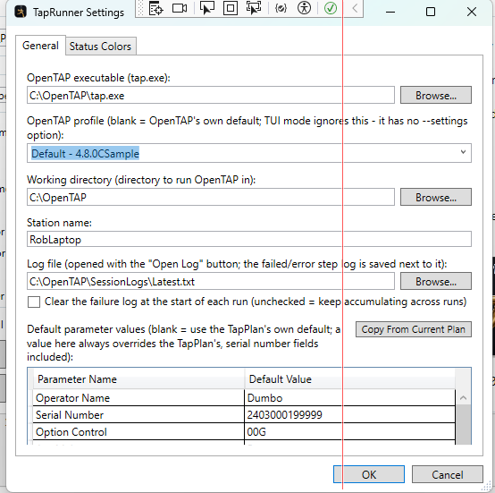
Field | What it's for
OpenTAP executable (tap.exe) | Full path to tap.exe. Defaults to C:\OpenTAP\tap.exe.
OpenTAP profile | Which bench settings profile to run with, picked from a dropdown of the profiles found under Settings\Bench next to tap.exe (or typed in directly). Leave blank to use OpenTAP's own default.
Working directory | The folder tap.exe is launched from.
Station name | Shown next to Operator in the main window. Defaults to the Windows computer name the first time TapRunner ever runs.
Log file | Where the running session log is written; the failure log is saved next to it automatically.
Clear the failure log at the start of each run | Off by default (the failure log keeps accumulating across runs, each headed with the plan name and start time). Turn on to have it hold only the current run's failures.
Default parameter values | A saved list of parameter name → value overrides that apply every time a matching plan loads - see "Running a Test" below. Copy From Current Plan fills this list from whatever's currently shown in the main window.
Status colors | The color (and whether it flashes) for each of the six status circles.
Click OK to save changes, or Cancel to discard them.
Running a Test
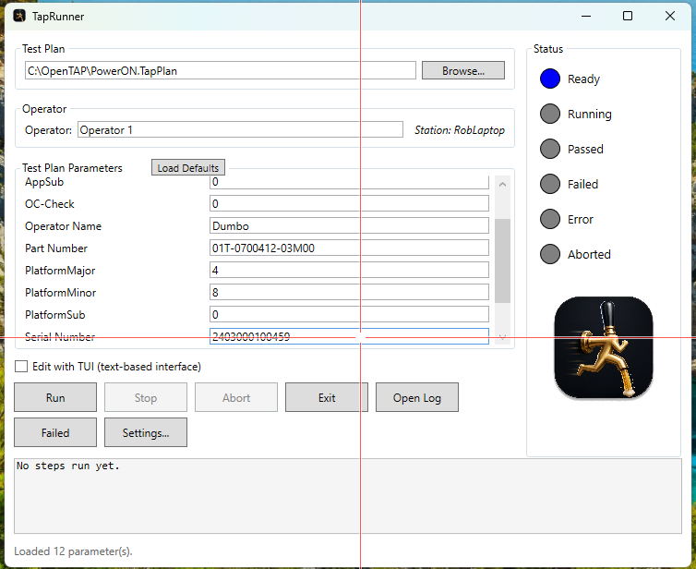
- Open a plan. Click Browse... and pick a .TapPlan file, or let TapRunner reopen the last one automatically on startup. Its external (test plan) parameters appear in a list, sorted alphabetically.
- Check the parameters. Any parameter with "serial" in its name gets keyboard focus automatically, with its value selected, so a barcode scan overwrites it in one motion. Other parameters are pre-filled from a saved default (Settings → Default parameter values) if one exists, otherwise from the plan's own default.
- Load Defaults, next to the parameter list, re-applies the saved defaults to what's currently shown - useful after changing them in Settings without reopening the plan. Anything typed by hand afterward is never overwritten automatically.
- Choose Run or Edit. With "Edit with TUI" unchecked, the button reads Run and launches the plan headless, passing along every parameter value. Checked, it reads Edit and opens OpenTAP's text-based interface instead - useful for stepping through or adjusting a plan by hand, though parameter values and the selected profile aren't passed through to TUI mode.
- Watch it run. TapRunner brings itself back to the front a moment after launching (the console window can otherwise steal focus), and the status circles, step history, and runtime clock update live - see "Status Indicators" below.
Status Indicators
Six circles on the right show the run's state, each lighting in its configured color (Settings → Status colors):
Circle | Lights when
Ready | Idle - no test currently running
Running | A plan is executing (flashes by default)
Passed | The run finished with a Pass verdict
Failed | The run finished with a Fail verdict; also lights half-on while running if any step fails, before the final verdict is known
Error | The run finished with an Error verdict, including if the process ended without ever reporting a result (never guessed as Ready)
Aborted | The run was stopped via Abort, or OpenTAP's own cooperative abort finished it
Below the circles and the logo sits a runtime clock (hh:mm:ss) that starts the moment tap.exe is launched and freezes the instant the run ends, so it's easy to see how long a run is taking or took.
The status line above the buttons shows "Running: <step name>..." as each step starts, even for steps that never publish a result. The scrollable box below the buttons keeps a running history of every completed step (name, verdict, and any published results), up to 1000 lines, growing from the top.
Stopping and Aborting a Run
Button | What it does
Stop | Asks OpenTAP to abort gracefully - it finishes the current step and runs any cleanup, then ends (usually with an Aborted verdict). Only works if TapRunner Status is enabled in OpenTAP's Results settings; otherwise use Abort.
Abort | Immediately kills the tap.exe process, with a confirmation prompt first. Use this if Stop isn't available or a run needs to end right away.
Closing TapRunner while a test is running also asks for confirmation, since doing so aborts the run.
Logs
Button | Opens
Open Log | The running session log, in whatever program the station uses for .txt files. Every status message and completed step is appended with a timestamp - it just keeps growing.
Failed | A separate TapRunner window listing every step that finished Fail or Error, with fuller detail than the main step history - the plan name and start time head each run's entries. Click Refresh to pick up new failures while a run is still in progress.
By default the failure log keeps accumulating across runs. Check Settings → Clear the failure log at the start of each run to have it hold only the most recent run's failures instead.
Troubleshooting
Symptom | Likely cause / fix
Status circles never move past Ready/Running | TapRunner Status isn't enabled as a result listener in OpenTAP (Settings → Results). Add/enable it - see "Installing TapRunner".
"The configured OpenTAP executable was not found" | Fix the path under Settings → OpenTAP executable (tap.exe).
Run finishes with Error and no clear reason | The process likely exited without reporting a result - a licensing error or startup failure is the most common cause. Check the session log (Open Log) for details.
Parameter values or the OpenTAP profile don't apply | Both are only passed through in headless Run mode - TUI ("Edit") mode doesn't accept either, by OpenTAP's own design.
A saved default parameter value doesn't show up | Check it's saved under the parameter's short name (e.g. PowerOn), not OpenTAP's full internal name (Parameters \ PowerOn).
Stop button has no effect | No status listener is currently connected for this run - use Abort instead.
Still stuck? Check the session log first (Open Log) - it records every status change during the run and is usually the fastest way to see what happened.

